***Faithful Navigator***- Luis Lopez

***Chaplain***- Fr. Peter Navarra

***Faithful Captain***- Ron Aguilar

***Faithful Pilot***- David Hall

***Faithful Admiral*** -J. Anthony Villaman

***Faithful Comptroller*** - Larry Frelke

***Faithful Scribe*** - A. Scott Graham

***Faithful Purser*** - Danny Fulkerson

***Inner Sentinel***- J. Russ Mullins

***Outer Sentinel***- Ernie Bonanno

***1 Year Trustee***- Dick Patrick

***2 Year Trustee***- Carl Ferreira

***3 Year Trustee***- Wesley Ciesielski

***Faithful Navigator***- J. Anthony Villaman

***Chaplain***-Fr. Peter Navarra

***Faithful Captain***-Luis Lopez

***Faithful Pilot***- Ron Aguilar

***Faithful Admiral*** - J “Jesse” Ramirez

***Faithful Comptroller*** - Larry Frelke

***Faithful Scribe*** - David Hall

***Faithful Purser*** - A. Scott Graham

***Inner Sentinel*** - Ernie Bonanno

***Outer Sentinel*** - J. Russ Mullins

***1 Year Trustee*** - Wesley Ciesielski

***2 Year Trustee*** - Dick Patrick

***3 Year Trustee*** - Carl Ferreira

**CY 2017-2018 Slate of Officers**

**CY 2016-2017Assembly Officers**

***Worthy Sir Knights,***

***The Assembly has gone dark this month because of Holy Week. May the Grace of the risen Christ be with you.***

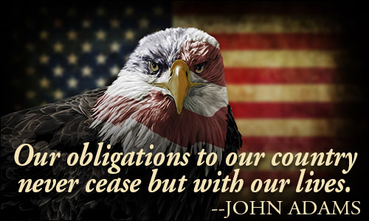

Faithful Navigator’s Report

J. Anthony Villaman

**CY 2016-2017**

**Vol. 1, # 10**

**April 2017**

Bishop C.B. Flores Assembly 3610

Submit

